ECON 101 – MACROECOMICS
FINAL EXAM
EXAMINER: Muhebullah Karimzada
December 09, 2025

Instructions:
1. You have 120 minutes to work on the exam.
2. This exam is individual and closed-book.
3. For the multiple-choice questions, choose the option that best answers/completes the question.
4. This Examination paper includes 17 pages (includes the cover page). You are responsible for ensuring that your copy of the paper is complete. Bring any discrepancy to the attentions of your invigilator.

PLEASE: PUT YOUR NAME AND STUDENT ID ON EVERY SHEET!!

Multiple Choice Answers:

1. _________ 17. _________ 33. _________ 49. _________ 65. _________

2. _________ 18. _________ 34. _________ 50. _________ 66. _________

3. _________ 19. _________ 35. _________ 51. _________ 67. _________

4. _________ 20. _________ 36. _________ 52. _________ 68. _________

5. _________ 21. _________ 37. _________ 53. _________ 69. _________

6. _________ 22. _________ 38. _________ 54. _________ 70. _________

7. _________ 23. _________ 39. _________ 55. _________ 71. _________

8. _________ 24. _________ 40. _________ 56. _________ 72. _________

9. _________ 25. _________ 41. _________ 57. _________ 73. _________

10. _________ 26. _________ 42. _________ 58. _________ 74. _________

11. _________ 27. _________ 43. _________ 59. _________ 75. _________

12. _________ 28. _________ 44. _________ 60. _________ 76. _________

13. _________ 29. _________ 45. _________ 61. _________ 77. _________

14. _________ 30. _________ 46. _________ 62. _________. 78. _________

15. _________ 31. _________ 47. _________ 63. _________ 79. _________

16. _________ 32. _________ 48. _________ 64. _________ 80. _________
MULTIPLE CHOICE. Choose the one alternative that best completes the statement or answers the question.

1) Which of the following would decrease the unemployment rate?
A) an increase in the minimum wage
B) an increase in the generosity of Employment Insurance payments
C) an increase in labour union membership
D) an increase in the efficiency wage
E) government aid to retrain unemployed workers

2) Short-run macroeconomic equilibrium occurs when
A) aggregate demand and short-run aggregate supply intersect.
B) the equilibrium lies on the long-run aggregate supply curve.
C) structural unemployment equal zero.
D) cyclical unemployment is equal to zero.
E) frictional unemployment equal zero.

3) Discouraged workers are classified by Statistics Canada as
A) unemployed.
B) part of the labour force.
C) part-time employees.
D) employed.
E) out of the labour force.

4) Which of the following explains why the unemployment rate tends to rise as a recession ends?
A) Employment insurance tends to be more generous during recessions.
B) The birth rate tends to rise during recessions.
C) Discouraged workers begin to search for jobs.
D) The federal government uses a different definition of "unemployed" during recession.
E) Firms reducing hiring as recessions come to an end.

5) If GDP is currently growing at 28 % a year, the velocity of money is growing at 1% a year, and the growth rate of money supply is 15%, what rate of inflation can this country expected based on the quantity theory of money?
A) -13%
B) 44%
C) -12%
D) 0.5%
E) 12%

6) The response of investment spending to an increase in the government budget deficit is called
A) expansionary investment.
B) crowding out.
C) private dissaving.
D) accelerating investment.
E) income minus net taxes.
7) Given the equations for C, I, G, and NX below, what is the equilibrium level of GDP?

C = 1,000 + 0.8Y
I = 1,500
G = 1,250
NX = 100

A) $3,080
B) $3,850
C) $6,930
D) $19,250
E) $38,500

8) The Bank of Canada uses ________ to measure inflation.
A) the GDP deflator
B) the producer price index
C) the index of leading economic indicators
D) the consumer price index
E) the personal consumption expenditures index

9) Which of the following causes the unemployment rate to understate the true extent of joblessness?
A) Persons who collect unemployment benefits report themselves to be searching for a job.
B) A drug dealer reports herself as unemployed.
C) Some people do not want to have a paid job.
D) Discouraged workers are not counted as unemployed.
E) Many full-time workers really want to be part-time workers.

10) On the 45-degree line diagram, the 45-degree line shows points where real aggregate expenditure equals
A) unplanned investment.
B) potential GDP.
C) planned investment.
D) nominal GDP.
E) real GDP.

11) If the economy receives an influx of new workers from immigration,
A) we will move down along the long-run aggregate supply curve.
B) the aggregate demand curve will shift to the left.
C) the long-run aggregate supply curve will shift to the left.
D) the long-run aggregate supply curve will shift to the right.
E) we will move up along the long-run aggregate supply curve.

Table 4.21
 | 2019 | 2020
Nominal GDP | $10,000 | $12,000
Real GDP | 9,500 | 10,500

12) Refer to Table 4.21. Given the information above, calculate the GDP deflator in 2019.
A) 87
B) 95
C) 100
D) 105
E) 114

13) If Canada and Bolivia have annual per capita growth rates of 3.2% and 1.35%, respectively, and if Canada's per capita GDP is higher, then in the long run
A) the difference between the level of real GDP per capita in Canada and real GDP per capita in Bolivia will equalize over time.
B) the difference between the level of real GDP per capita in Canada and real GDP per capita in Bolivia will increase over time.
C) the difference between the level of real GDP per capita in Canada and real GDP per capita in Bolivia will always be $1.9 trillion.
D) the difference between the level of real GDP per capita in Canada and real GDP per capita in Bolivia will shrink over time.
E) real GDP per capita in Canada will always be 1.9% higher than real GDP per capital in Bolivia.

14) When U.S. GDP grows more slowly compared to Canada,
A) Canadians will export some of the newly made Canadian goods, causing U.S. GDP to shrink.
B) government spending in Canada will likely decrease.
C) Canadian prices will rise more quickly causing household disposable income to fall in Canada.
D) Canadian firms will invest more, causing domestic investment to rise and Canadian GDP to fall.
E) Canadian firms will export less, leading to slower Canadian GDP growth.

15) Using the money demand and money supply model, an open market sale of government of Canada securities by the Bank of Canada would cause the equilibrium interest rate to
A) increase.
B) decrease.
C) not change.
D) increase, then decrease.
E) decrease, then increase.

16) If, in a closed economy, real GDP is $30 billion, consumption is $20 billion, and government purchases are $5 billion, what is total saving in the economy?
A) $5 billion
B) $15 billion
C) $25 billion
D) $45 billion
E) $55 billion

17) Which of the following is not counted in M1+?
A) chequing account balances
B) non-chequable deposits
C) currency in circulation
D) credit card balances
E) coins in circulation

18) Which of the following is considered a negative supply shock?
A) a decline in wages
B) an unexpected increase in the price of natural gas
C) increasing investment in the economy causes the capital stock to rise
D) an improvement in technology
E) a drop in investment spending

19) In preparing their estimates of the economic impact of a new football stadium in the City of Regina, proponents argued that building the stadium would create twice as much economic activity in the city as the stadium was projected to cost (essentially arguing that the local multiplier was 2). This is likely to be an overestimate of the multiplier because
A) construction projects generate no additional economic activity.
B) Regina's marginal propensity to consume is too great.
C) imports and income taxes will reduce the impact of new spending.
D) the price level in the local economy is likely to be insensitive to a major construction project.
E) the marginal propensity to save in Saskatchewan is much higher than in other parts of the country.

20) High-income countries have ________ and ________ as compared to developing countries.
A) low rates of savings; low rates of unemployment
B) low rates of savings; low rates of growth
C) high rates of savings; high rates of unemployment
D) high rates of savings; high rates of growth
E) low rates of savings; high rates of growth

21) Most economists believe that the return of ________ during the 2008-2009 recession is a key reason why the recession was so severe.
A) high tariffs
B) financial instability
C) high interest rates
D) high unemployment
E) rapid inflation
22) When lumber from Brazilian forests is used by a U.S.-owned company to produce furniture in Canada, the value of the furniture produced will be counted as a final good in
A) U.S. GDP.
B) Brazil's GNP.
C) Canada's GDP.
D) Brazil's GDP.
E) Brazil's GNI.

23) Poorly timed discretionary policy can do more harm than good. Getting the timing right with fiscal policy is generally
A) about the same difficulty as with monetary policy.
B) less difficult than with monetary policy.
C) more difficult than with monetary policy.
D) far less difficult than with monetary policy.
E) impossible due to the interference from the Bank of Canada.

24) If planned aggregate expenditure is greater than total production,
A) actual inventories will equal planned inventories.
B) firms will experience an unplanned increase in inventories.
C) GDP will increase.
D) governments are likely to experience growing budget deficits.
E) the economy is in equilibrium.

25) Which of the following will cause a direct increase in consumption spending?
A) a decrease in net export spending
B) an increase in planned investment
C) an increase in income taxes
D) an increase in disposable income
E) an increase in government spending

26) Which of the following best describes the "wealth effect"?
A) When the price level falls, the nominal value of household wealth rises.
B) When the price level falls, the value of stocks rise.
C) When the price level falls, the real value of household wealth rises.
D) When the price level falls, the nominal value of household wealth falls.
E) When the price level falls, the real value of household wealth falls.

Table 10.3
Assets | Liabilities
Reserves +$7,000 | Deposits +$50,000
Loans +$46,000 | Net Worth +$3,000

27) Refer to Table 10.3. Consider the following simplified balance sheet for a bank: If the desired reserve ratio is 10 percent, the bank can make a maximum loan of
A) $2,000.
B) $3,000.
C) $5,000.
D) $6,300.
E) $45,000.

28) Which of the following is most liquid?
A) a corporate bond
B) a five dollar bill
C) a government bond
D) a painting
E) a mutual fund share

29) Suppose real GDP is $1.4 trillion and potential GDP is $1.9 trillion. To move the economy back to potential GDP, the federal government should
A) lower taxes by $500 billion.
B) lower taxes by an amount less than $500 billion.
C) raise government purchases by more than $500 billion.
D) raise government purchases by $500 billion.
E) lower government purchases by $500 billion.

30) If real GDP grows by 7.0% in 2018, falls by 3% in 2019, and grows by 6% in 2020, what is the average annual growth rate of real GDP?
A) 1.4%
B) 2.9%
C) 3.3%
D) 4.2%
E) 5.3%

31) An increase in ________ shifts the production function ________, and makes it possible to produce a higher level of GDP with ________ capital per hour worked.
A) technology; down; the same amount of
B) capital stock; up; a lesser amount
C) consumption; up; a lesser amount
D) labour productivity; down; the same amount of
E) technology; up; the same amount of

32) The decrease in consumer spending during the 2008-2009 recession was due in part to falling prices in the stock market. The reason for the decline in consumer spending is most closely related to which of the following variables that determine the level of consumption?
A) the price level
B) household wealth
C) government transfers
D) current disposable income
E) the interest rate

33) If the government purchases multiplier equals 2, and real GDP is $1.7 trillion with potential real GDP of $1.75 trillion, then government purchases would need to increase by ________ to restore the economy to potential real GDP.
A) $1.75 trillion
B) $500 billion
C) $100 billion
D) $50 billion
E) $25 billion

34) If nominal GDP exceeds real GDP for a specific year, then the GDP deflator must be
A) equal to 100.
B) greater than 100.
C) less than 100.
D) equal to its value in the base year.
E) less than 0.

35) Which of the following could explain why there is an increase in potential GDP but the equilibrium level of GDP does not rise?
A) SRAS shifted to the right by more than LRAS.
B) The shift in LRAS was caused by a rise in investment.
C) AD shifted to the right by more than SRAS.
D) SRAS and AD do not shift.
E) AD shifted to the right by less than SRAS.

36) Which of the following would not be included in the expenditure category called investment expenditures?
A) a purchase of a copy machine by Purolator Courier's head office
B) spending on new houses
C) a purchase of shares of preferred stock
D) the cars held in inventory on a local Ford dealer's lot
E) the purchase of a new airplane by Air Canada

Figure 8.3

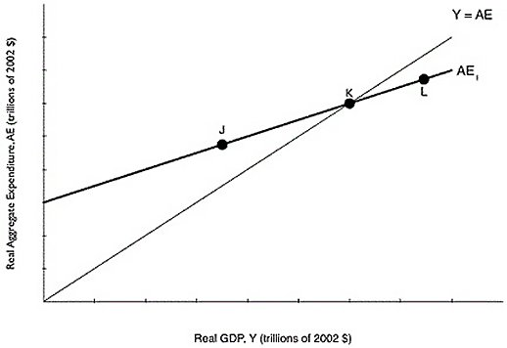
37) Refer to Figure 8.3. If the economy is at point J, what will happen?
A) Inventories have fallen below their desired level, so firms will decrease production.
B) Inventories have risen above their desired level, so firms will increase unplanned inventory investment.
C) Inventories have risen above their desired level, so firms will decrease production.
D) Inventories have fallen below their desired level, so firms will decrease unplanned inventory investment.
E) Inventories have fallen below their desired level, so firms will increase production.

38) The "new economy" which some economists believe can lead to higher productivity growth in the future is based on
A) information technology.
B) financial services.
C) natural resource extraction.
D) manufacturing.
E) retail sales.

39) Suppose the economy is at a short-run equilibrium GDP that lies below potential GDP. Which of the following will occur because of the automatic mechanism adjusting the economy back to potential GDP?
A) Short-run aggregate supply will shift to the right.
B) Output will decrease.
C) Aggregate demand will shift to the right.
D) Unemployment will rise.
E) Prices will increase.

40) In the long run,
A) the aggregate demand curve becomes flat.
B) LRAS and SRAS lie on the same line.
C) the inflation rate is zero.
D) unemployment is at its natural rate.
E) GDP > potential GDP.

41) The purchase of a new house is included in
A) investment expenditures.
B) government purchases.
C) imports.
D) consumption expenditures.
E) exports.

42) In a small Asian country, it is estimated that a $10,000 increase in capital per hour worked will increase real GDP per hour worked by $600. Based on this information, what is the slope of the per-worker production function in this range?
A) 0.0
B) 0.06
C) 0.6
D) 6.6
E) 66.6
43) An increase in aggregate demand in the economy will have what effect on macroeconomic equilibrium in the long run?
A) The price level will rise and the level of GDP will be unaffected.
B) The price level will be unaffected and the level of GDP will rise.
C) The price level will rise and the level of GDP will fall.
D) The price level will fall and the level of GDP will rise.
E) The price level will fall and the level of GDP will fall.

44) Which of the following explains the changes in the Canadian adult male labour force participation rate since 1976?
A) There are fewer working age males than in the past.
B) Younger men are remaining in school longer as compared to the past.
C) More men are joining the military as compared to the past.
D) More men are retiring later in life as compared to the past.
E) Fewer men consider themselves discouraged workers as compared to the past.

45) There are no costs to inflation if it is fully anticipated.
A) True
B) False

46) The body that is responsible for dating the beginning and ending dates for a recession is
A) the Bank of Canada.
B) Canadian Parliament.
C) the Association of Chief Economics of Canadian Banks.
D) Statistics Canada.
E) There is no such body in Canada.

47) The aggregate demand curve will shift to the right ________ the initial decrease in taxes.
A) by less than
B) by more than
C) by the same amount
D) sometimes by more than and other times by less than
E) None of the above.

48) Which of the following tools of monetary policy is used least often?
A) sale and repurchase agreements
B) setting the overnight interest rate
C) acting as a lender of last resort
D) printing more money
E) purchase and resale agreements

49) The per-worker production function has a ________ slope, indicating that increases in capital per hour worked ________ real GDP.
A) negative; increase
B) positive; increase
C) positive; decrease
D) negative; decrease
E) vertical; decrease
50) Which of the following is an objective of fiscal policy?
A) winning hockey gold at the winter Olympics
B) high rates of economic growth
C) drug plan coverage for all Canadians
D) energy independence from Middle East oil
E) discovering a cure for AIDs

51) Paul Romer, an economist at Stanford University, is most closely associated with what economic theory?
A) the process of creative destruction
B) labour productivity theory
C) the Communist Manifesto
D) new growth theory
E) the quantity theory of money

Table 5.19
Year | Nominal Average Hourly Earnings | CPI  (2002 = 100)
2017 | $23.00 | 119.9
2018 | 23.50 | 121.7
2019 | 24.00 | 122.8

52) Refer to Table 5.19. Looking at the table above, what is the rate of growth of real average hourly earnings from 2018 to 2019?
A) 1.2%
B) 2%
C) 4.3%
D) -1%
E) -1.8 %

53) The largest component of spending in GDP is
A) wages.
B) government spending.
C) net export spending.
D) household spending.
E) investment spending.

54) Caroline is an artist. She purchases canvas, paints, brushes, and accessories for $75. She sells one of her original paintings to an art gallery for $1,500. The gallery, in turn, sells the painting to an art lover for $4,500. How much value does the gallery add?
A) $1,425
B) $1,500
C) $3,000
D) $4,500
E) $5,075

55) A monetary growth rule means that
A) the Bank of Canada will raise interest rates if it thinks the economy is growing faster than potential.
B) the money supply should grow at a constant rate.
C) the money supply should grow in response to economic conditions.
D) the money supply should grow at the same rate as the population.
E) the Bank of Canada will lower interest rates if it thinks a recession is on the horizon.

56) Increases in real GDP since 1961 can actually underestimate growth in the standard of living for Canadians because
A) the quality of health care that exists today was not available in 1961.
B) the crime rate was higher in 1961 than it is today.
C) fewer women participated in the paid labour force in 1961.
D) goods and services are more expensive today as compared to 1961.
E) the level of pollution in 1961 was much higher than it is today.

Table 5.15
Year | Nominal Average  Hourly Earnings | CPI
2017 | $15 | 100
2018 | 15 | 105
2019 | 18 | 110

57) Refer to Table 5.15. Looking at the table above, real average hourly earnings were equal to ________ in 2018.
A) $13.63
B) $14.29
C) $15.00
D) $16.50
E) $18.36

58) The two main monetary policy tools used by the Bank of Canada to implement monetary policy are
A) tax rates and printing money.
B) tax rates and lending to financial institutions.
C) lending to financial institutions and changing the desired reserve ratio.
D) open market operations and tax rates.
E) open market operations and lending to financial institutions.

59) Which of the following would be the best measure of the cost of living?
A) real GDP
B) purchasing managers' index
C) GDP deflator
D) real GDP per person
E) consumer price index

60) If real GDP in a closed economy is $40 billion, consumption is $20 billion, and government purchases are $10 billion, what is investment?
A) $10 billion
B) $30 billion
C) $40 billion
D) $55 billion
E) $70 billion

61) A commercial bank like Bank of Montreal creates money by
A) distributing new currency printed by the Canadian mint.
B) earning profits.
C) printing paper money.
D) selling corporate bonds.
E) making loans.

62) Examples of assets that are included in household wealth would be
A) stocks, bonds, and household appliances.
B) stocks, bonds, and mortgages.
C) stocks, bonds, and savings accounts.
D) stocks, credit cards, and savings accounts.
E) stocks, loans owed, and savings accounts.

63) An increase in net national income could be caused by which of the following?
A) an increase in depreciation
B) an increase in housing costs
C) an increase in personal taxes
D) a decrease in personal income
E) an increase in gross domestic product

Table 4.20
 | 2018 |  | 2020
Product | Quantity | Price | Quantity | Price
Cameras | 100 | $10 | 120 | $12
Legal services | 50 | 15 | 45 | 20
Books | 200 | 40 | 210 | 45

A very simple economy produces three goods: cameras, legal services, and books. The quantities produced and their corresponding prices for 2018 and 2020 are shown in the table above.

64) Refer to Table 4.20. What is real GDP in 2020, using 2020 as the base year?
A) $28,885
B) $11,790
C) $11,200
D) $10,275
E) $8,750

65) In a small economy in 2016, aggregate expenditure was $850 million while GDP that year was $800 million. Which of the following can explain the difference between aggregate expenditure and GDP that year?
A) Firm investment in inventories was greater than anticipated in 2016.
B) Aggregate expenditure is always less than GDP in developing countries.
C) Firm investment in inventories was less than anticipated in 2016.
D) Aggregate expenditure is always less than GDP in developed countries.
E) Aggregate expenditure does not account for consumer spending.

66) Georg, a German citizen, just purchased 10 shares of stock in Suncor, a Canadian company. This purchase is an example of
A) foreign direct investment.
B) contractual globalization.
C) domestic fixed capital formation.
D) foreign public investment.
E) foreign portfolio investment.

67) Using the quantity equation, if the velocity of money grows at 5 percent, the money supply grows at 10 percent, and real GDP grows at 4 percent, then the inflation rate will be
A) 14 percent.
B) 15 percent.
C) 6 percent.
D) 19 percent.
E) 11 percent.

68) Workers and firms both expect that prices will be 2.5% higher next year than they are this year. As a result
A) aggregate demand will increase by 2.5%.
B) long-run aggregate supply will shift to the right by 2.5%.
C) workers will be willing to take lower wages next year, but not lower than a 2.5 percent decrease.
D) the purchasing power of wages will rise if wages increase by 2.5%.
E) the short-run aggregate supply curve will shift to the left as wages increase.

69) If the nominal interest rate is 6% and the inflation rate is 9%, then the real interest rate is
A) -3%.
B) 3%.
C) 6.67%.
D) 15%.
E) 25%.

Figure 9.3

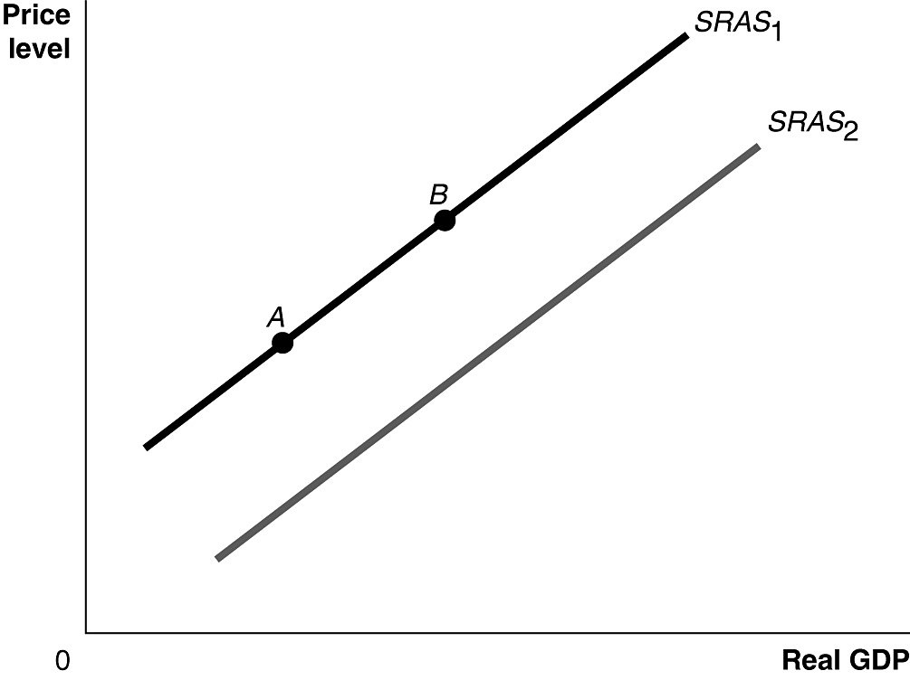

70) Refer to Figure 9.3. Ceteris paribus, an increase in the expected price of an important natural resource would be represented by a movement from
A) SRAS1 to SRAS2.
B) SRAS2 to SRAS1.
C) point A to point B.
D) point B to point A.
E) point 0 to point A.

71) The Bank of Canada maintains an operating band for the overnight interest rate of
A) 50 basis points above the prime rate.
B) 50 basis points below the inflation rate.
C) 50 basis points below the bank rate.
D) 50 percent of the bank rate.
E) 50 percent of the inflation rate.

Figure 7.3

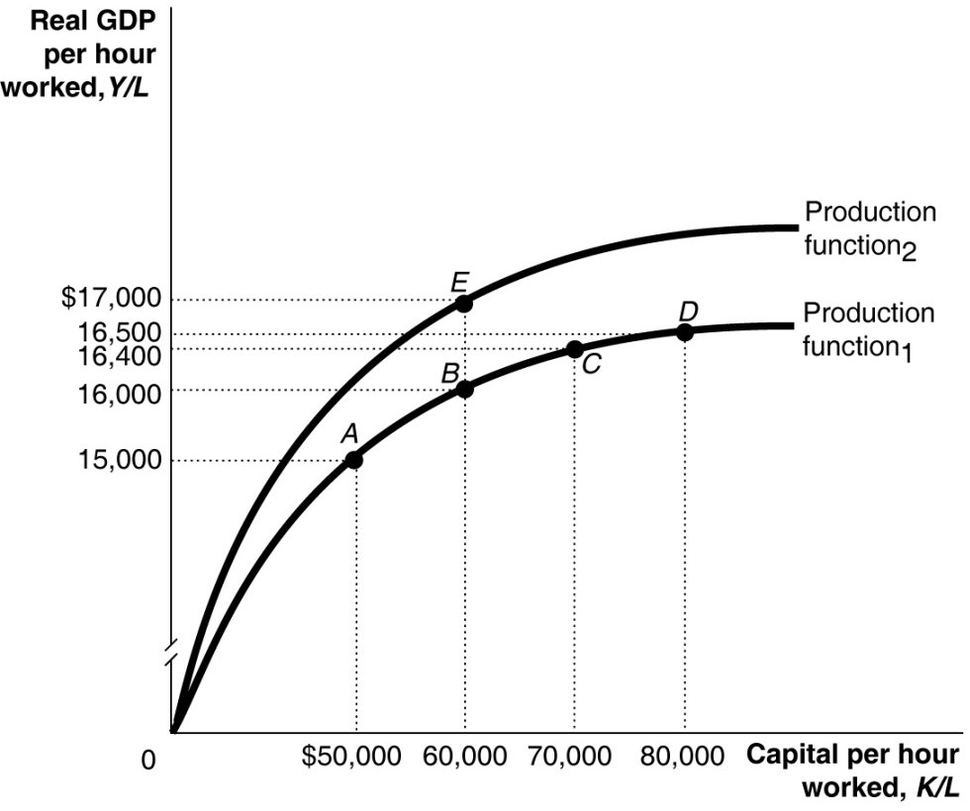

72) Refer to Figure 7.3. A large group of new workers entering the labour force is shown in the figure above by a movement from
A) C to D.
B) C to B.
C) A to B.
D) B to E.
E) E to B.

73) A decrease in the real interest rate will
A) most likely transfer wealth from borrowers to lenders.
B) most likely increase the cost of borrowing.
C) most likely increase consumer purchases of durable goods.
D) cause consumers to spend less and save more.
E) most likely increase the reward to savings.

74) In October 2008, U.S. Congress passed the Troubled Asset Relief Program (TARP), under which the U.S. Treasury Department provided ________ to banks in exchange for ________.
A) funds; stock
B) bonds; cash
C) financial advice; promises to expand mortgage lending
D) deposits; new mortgage loans
E) lines of credit; loan guarantees

75) An increase in the purchasing power of money would not, on average, result in an increase in the purchasing power of people's income because a ________ price level would likely mean ________ wages and salaries.
A) rising; falling
B) falling; rising
C) falling; no changes in
D) falling; falling
E) rising; rising

76) Which of the following is an example of human capital?
A) a university or college education
B) computers used by human resource departments
C) a computer
D) a software program
E) a factory building

77) Active changes in tax and spending by government intended to smooth out the business cycle are called ________, and changes in taxes and spending that occur passively over the business cycle are called ________.
A) active monetary policy; passive monetary policy
B) discretionary fiscal policy; conscious fiscal policy
C) discretionary fiscal policy; automatic stabilizers
D) automatic stabilizers; monetary policy
E) automatic stabilizers; discretionary fiscal policy

78) A government tax rebate of $1,000 would ________ your disposable income by ________.
A) decrease; $1,000
B) increase; $500
C) decrease; less than $1,000
D) increase; $1,000
E) increase; less than $1,000

79) Which of the following would be a consequence of substitution bias in the CPI?
A) Economists make errors in estimating inflation when using substitutes for the CPI such as GDP deflator.
B) Businesses would overcompensate employees for inflation when giving the cost of living rises.
C) The inflation rate based on the CPI would underestimate the true level of inflation.
D) Social Security payments would not adequately compensate retired workers for inflation.
E) Judges would award child support payments that would not adequately keep up with the true cost of inflation.

80) A decrease in which of the following would decrease the tax wedge?
A) federal budget deficit
B) marginal tax rate
C) property taxes
D) money supply
E) national debt

